Protocol 1

Kingfisher plates and elution strips:

Incubation 1:
Row A: sample type 1 (green * tips touching these cannot be reused*)
C,D,E: negative beads in buffer 2 (red)
F,G,H: buffer 1 (blue)
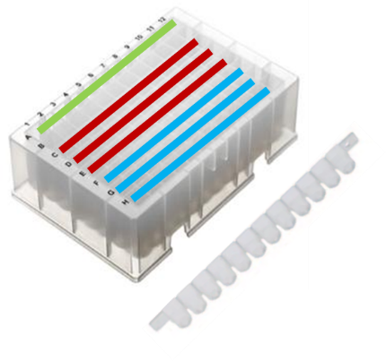

Incubation 2:
Row A: sample type 1 (green)
C: beads with sample type 2 in buffer 2 (red)
D,E,F: buffer 1 (blue)
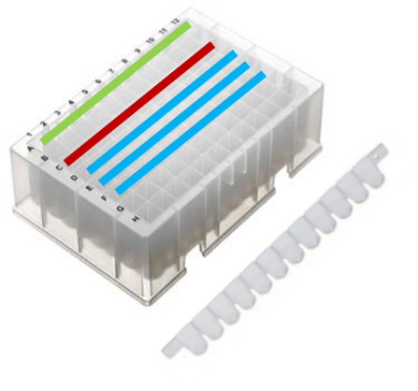

Bead preparation:
- 25 uL beads per positive sample type 1 (can be store in one tube/well per sample type 2). In the following, 3 sample type 1 and 2 sample samples type 2 is used as an example.
- 3 negative beads of 20uL per N=sample type 1 * sample type 2, so for N=6, 18 negative beads are needed: 18 x 20uL = 360 uL
Prep of beads for incubation 1:
- Take beads, here 360 uL of homogenized bead solution
- Wash the beads 2x with 500 uL of buffer 1 & resuspend the beads in the initial volume = 360 uL of buffer 1
- Add buffer 3: 18 x 5 = 90 uL
- Incubate at RT for 30 min on shaking device (mix by pipetting?)
- Wash the beads 2x with 500 uL of buffer 1
- Finally resuspend the beads with 910uL buffer 2 and distribute 50uL to wells in row C,D,E
- Top up beads with 50uL buffer 2 (only due to robot requirements, perhaps not necessary in OT2?)

Prep of beads for incubation 2:
- Take beads, here 150 uL of homogenized bead solution
- Wash the beads 2x with 500 uL of buffer 1
- Resuspend the beads in the initial volume = 150 uL of buffer 1
- Split into n* 50 uL (n=number of sample type 2=here 2), so 2*50uL=100uL
- Add user specified volume of sample type 2 (should be kept cooled - need for pause and user added?)
- Incubate 30 min at 4C 500 rpm (corresponding mix by pipetting?)
- Wash the beads 1x with 500 uL of buffer 1
- Resuspend in 100 uL of buffer 1
- Add 10 uL of buffer 3
- Incubate 10 more minutes
- wash the beads 2x with 500 uL of buffer 1
- Finally resuspend the beads with 610 uL of buffer 2
- Distribute 100 uL of beads to the wells of the kingfisher plate for incubation 2 in row C.

Preparation of plates for incubation 1 and 2:
- Prepare the mastermix (MM). N = N(samples) * 3 + 3 negative controls + 1 excess. Here N=22:
Reagents | Per Reaction | For 22 reactions
water | 16.7 | 367,4
Buffer 3 | 5 | 110
Buffer 4 | 2.5 | 55
Primer 1 | 0.4 | 8,8
Primer 4 | 0.4 | 8,8
- Add 25 uL of MM in the wells of the two elution strips (in as many wells as needed) and place them in the king fisher
- Add 200uL buffer 1 wells in row F,G,H in plate for incubation 1 and D,E,F in plate for incubation 2 as shown below:
Neg | 1 | 2 | 3 | 4 | 5 | 6 | 7 | 8 | 9 | 10 | 11 | 12
A
B
C
D
E
F
G
H

pos | 1 | 2 | 3 | 4 | 5 | 6 | 7 | 8 | 9 | 10 | 11 | 12
A
B
C
D
E
F
G
H

- Store positive plate back in the fridge at 4 degrees Celsius
- Add the sample type 1 to row A of the negative plate and top up to 150uL with buffer 2 (due to instrument requirement)
- The incubation 1 plate should now look like this:
 | 1 | 2 | 3 | 4 | 5 | 6 | 7 | 8 | 9 | 10 | 11 | 12
A | Sample type 1 + buffer 2
B
C | beads
D
E
F | Buffer 1
G
H

And plate 2:
 | 1 | 2 | 3 | 4 | 5 | 6 | 7 | 8 | 9 | 10 | 11 | 12
A | Free (for sample type 1 after incubation 1)
B
C | Beads (w/ sample type 2)
D | Washing steps
E
F
G
H

Steps in incubation 1:
- Sample type 1 is in row A (in volume: 50-150 µL depending on instrument requirements)
- Beads (without buffer) transferred from row C to sample in row A, incubated for 30 min at 4 or 37 °C with shaking and beads are transferred back to row C without liquid.
- Step 2 is repeated for beads in row D
- Step 2 is repeated for beads in row E but instead of being transferred back to row E they beads are washed by incubated for 45 sec in row F, G and H with shaking
- Beads are collected from row H and resuspended in 30 µL MM in the elution strip
- 1 µL sample type 1 in row A is diluted in 99 µL buffer 5

Steps in incubation 2:
- Pause for addition of new reagents (only if necessary)
- **Repeat step 1-5 from incubation 1 using sample type 1 from row A (in incubation 1) but with only 1 round of bead incubation instead of 3 (as shown in kingfisher plate for incubation 2)**
- Samples for further analysis are beads in MM from incubation 1 and incubation 2, diluted sample type 1 (1:100) after incubation 1 and sample type 1 after incubation 2
Final bead prep:
- Beads in MM after incubation 1 and incubation 2 are incubated 5 min at 95 °C
- Immediately after, the entire 30 µL MM are mixed with 25 µL buffer 6 in 0,2mL PCR tubes/skirted plate.

Protocol 2

NGS prep (sample and buffer annotation does not apply here)
Preparation for PCR1 (DNA samples in 96-well skirted plate) currently done row-wise:
- Dilute 1 µL of each sample into 9 µL of water in a new 96-well plate, currently done row-wise (blue=sample liquid). :
 | n1 | n2 | n3 | n4 | n5 | 6 | 7 | 8 | 9 | 10 | 11 | 12
Sample 1
Sample 2
Sample 3
Sample 4
*n may vary from 3 to 6*

- PCR1 mix: all samples have the same reverse primer, unique forward primers for each column (n1, n2 etc.) and the number of reactions per column is R=samples per row * 2 + 2 + 1 (for duplicates, dead volume and no-template control). Here, R=4*2+2+1=11:
 | 1x (V in µL) | 11x
PCR MM | 10 | 110
Forward primer | 0,1 | 1,1 (dilution needed for accurate pipetting?)
Reverse primer | 0,1 | 1,1
Template DNA | 1 | -
Water | 8,8 | 96,8

- PCR 1 plate - 19 µL PCR1 mix added to new 0,2mL PCR skirted plate for PCR in duplicates (see attached excel sheet for example primer combinations for PCR1 and PCR2 * it would be great if this sheet can be provided be the user to the script*):
 | n1 | n1 | n2 | n2 | n3 | n3 | n4 | n4 | n5 | n5
Sample 1
Sample 2
Sample 3
Sample 4
 | control |  | control |  | control |  | control |  | control

- 1 µL DNA sample from 1:10 dilution (step 1) added to corresponding wells in PCR 1 plate (n1, n2 etc.)
- Pause for qPCR on different machine (option to run PCR in OT2 with user specified cycle number and melting, annealing and elongation temperatures added to script)
*Pause for normalization*
Preparation for PCR2 – for each pool PCR2 is performed in replicates:
- The number of replicates per pool is: 4, 3 and 2 replicates are made for <6, 6-7 and 8 sample, resp.
- Forward and reverse primers are contained in separate tubes and each sample needs individual primer combinations (see attached excel sheet for example primer combinations)

- PCR2 mix – primer pairs are unique for each pool:
 | 1x (V in µL) | Mastermix of 6x per sample (1 added for dead volume)
PCR MM | 10 | 60
Forward primer | 0,1 | 0,6
Reverse primer | 0,1 | 0,6
Template DNA | 5 | -
Water | 4,8 | 28,8
- PCR2 mix is added to skirted 96-well PCR plate, in this current example like so: mastermix is distributed to each row and template DNA is added to replicates
 | Replicate 1 | Replicate 2 | Replicate 3 | Replicate 4
Sample 1 |  |  |  |  |  |  |  |  |  | Control
Sample 2 |  |  |  |  |  |  |  |  |  | Control
Sample 3 |  |  |  |  |  |  |  |  |  | Control
Sample 4 |  |  |  |  |  |  |  |  |  | Control

- Program is stopped before PCR2 is run in thermocycler (unless qPCR can be incorporated)

